Research Report On:-Improper Inventory Management



Introduction
Inventory management is critical in cybersecurity to ensure that all assets, including hardware, software, and data, are accounted for and protected. Proper inventory management helps organizations maintain visibility over their IT assets, identify vulnerabilities, and implement timely security measures. However, improper inventory management can lead to security gaps, data breaches, and compliance failures.

What is Improper Inventory Management in Cybersecurity?
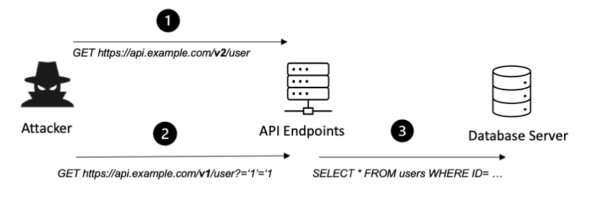
Improper inventory management in cybersecurity refers to the failure to maintain accurate and up-to-date records of IT assets, including hardware, software, and sensitive data. This can result from inadequate tools, lack of policies, or human errors.

Characteristics of Improper Inventory Management in Cybersecurity:
- Lack of comprehensive asset inventory.
- Untracked or unmanaged hardware and software.
- Outdated records of software versions and patches.
- Failure to classify and secure sensitive data.
- Inadequate monitoring of third-party assets.

Impact of Improper Inventory Management in Cybersecurity

1. Increased Risk of Data Breaches
- Unpatched Systems: Untracked software may miss critical security updates, leaving vulnerabilities exploitable.
- Unmanaged Devices: Unauthorized or rogue devices on the network can become entry points for attackers.

2. Non-Compliance Penalties
- Regulatory Violations: Industries governed by regulations such as GDPR, HIPAA, or PCI DSS require accurate asset management. Failure to comply can result in fines and legal consequences.

3. Operational Disruptions
- Incident Response Delays: Without accurate asset inventory, identifying affected systems during a cyber incident becomes time-consuming.
- Inefficient Resource Allocation: Resources may be wasted on securing irrelevant or non-existent assets.

4. Shadow IT Risks
- Unapproved Software and Hardware: Employees may use unregistered tools, creating vulnerabilities.
- Visibility Gaps: IT teams may fail to monitor and secure these assets effectively.

5. Increased Costs
- Duplicate Licensing: Without clear records, organizations may over-purchase software licenses.
- Security Breach Costs: Data breaches resulting from mismanaged assets can lead to financial losses and reputational damage.

Examples and Case Studies

1. Equifax Data Breach (2017)
Scenario: A major data breach exposed the personal information of 147 million people. Issues:
- Failure to patch a known vulnerability in untracked software.
- Lack of a comprehensive asset inventory. Outcome: The breach cost Equifax over $1.4 billion in settlements and damages.

2. Target Data Breach (2013)
Scenario: Attackers gained access to Target’s network through a third-party vendor. Issues:
- Poor inventory management of third-party systems.
- Failure to monitor vendor access. Outcome: The breach affected 40 million customers and cost Target $202 million.

3. Shadow IT in Financial Sector
Scenario: A financial firm discovered that employees were using unauthorized cloud storage services. Issues:
- Lack of visibility into employee-installed software.
- Unsecured sensitive financial data. Outcome: The firm faced compliance violations and reputational harm.

Issues in Improper Inventory Management in Cybersecurity

1. Lack of Asset Discovery Tools
Organizations without automated tools fail to detect and monitor all IT assets.

2. Absence of Policies and Procedures
A lack of clear guidelines for asset tracking and maintenance increases the risk of mismanagement.

3. Poor Integration
Disconnected systems across departments hinder real-time visibility into asset status.

4. Inadequate Training
Employees without cybersecurity training may unintentionally bypass inventory protocols.

5. Over-reliance on Manual Processes
Manual tracking is error-prone and inefficient for managing large-scale IT inventories.

Knowledge Gained
- Asset Visibility: Implementing automated asset discovery and tracking tools is essential for maintaining security.
- Patch Management: Ensuring all tracked software is updated reduces vulnerabilities.
- Data Classification: Properly classifying and securing sensitive data improves compliance and reduces risk.
- Third-Party Management: Monitoring vendor systems and access points mitigates external threats.
- Policy Development: Establishing clear policies and training staff enhances overall inventory management.

References
- Chaffey, D. (2018). "Digital Business and E-commerce Management." Pearson Education.
- Ponemon Institute. "Cost of a Data Breach Report." (2021).
- Harvard Business Review. "Why Target’s Canadian Expansion Failed." (2015).
- Bloomberg. "Equifax Data Breach Settlement." (2018).
- NIST. "Cybersecurity Framework: Asset Management." (2020).
- World Economic Forum. "The Risks of Shadow IT." (2021).

